Logging into VCL
- Go to https://vcl.whittier.edu
- Click “Proceed to Login”
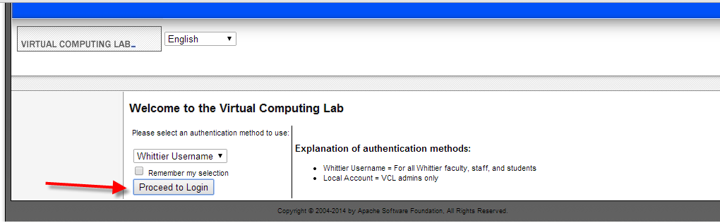
- Enter your my.whittier.edu username and password and click “login”
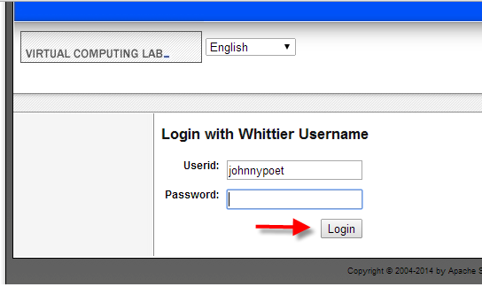
- On the landing page click “New Reservation” on the left pane.
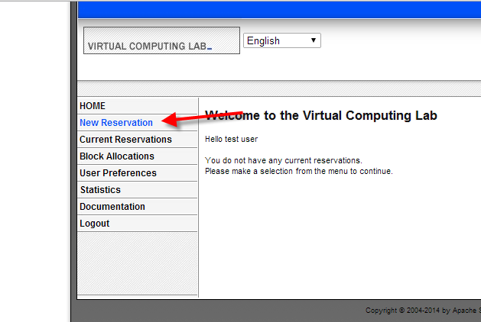
- Depending on your lab, choose the appropriate image and click “Create Reservation” button
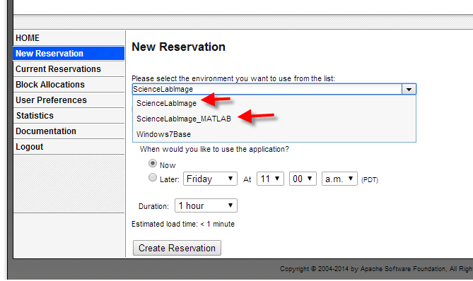
- After about one minute a button will appear “Connect!”
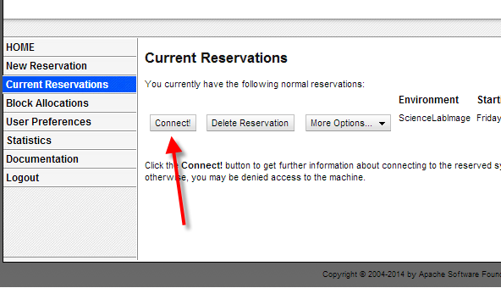
- Click “Get RDP File” and open the file, enter the randomly generated password show in the Password field.
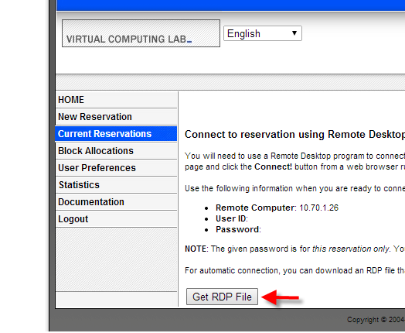
- If everything is connected you should see the lab desktop. Congratulations!
